

Egypt University of Informatics

Computer and Information Systems

Data Analysis Course

Research for studying the effect of a project on course material understanding.

Submitted by: youssef yasser faltas

9/3/2024

# Introduction

* In this study, we are examining the impact of integrating projects into coursework on student learning outcomes and its potential for enhancement. The findings from this research are of significance to academic administrators and faculty members, as they can use them to refine their teaching strategies and enhance student comprehension of course materials.

# Research Question

* Does having a project as part of the coursework beneficial to students and improves their grades and understanding of the course?

# Hypothesis

* The hypothesis is that having a project included as part of the course will improve understanding, enhance motivation, and reinforce learning. Also, it will make the students gain practical experience and make the course more engaging.

# Population of Interest:

* The population of interest is the students who have been enrolled in a course that included a project as part of its coursework.

# Sampling Method:

* The sampling technique employed in this study is referred to as simple random sampling. This method involves randomly selecting a sample from the population to respond to the survey questions.

# Bias Identification:

* During the process of conducting this survey, it was ensured that no bias would occur by offering this set of questions to all genders, of all ages, with no restrictions.
* Additionally, we have included specific questions designed to detect any potential bias in the survey.

# Survey Questions:

* Gender
* Age
* Academic level
* Major
* Have you ever been enrolled in a course that included a project as part of its coursework?
* What was your grade in that course?
* How would you rate your understanding of the course materials?
* Do you believe that having a project positively impacted your overall performance in the course?
* If you believe that having a project positively impacted your performance, how did it contribute?

Online survey link: <https://docs.google.com/forms/d/e/1FAIpQLSe-T4EXOysFY02sCba-QPJo2V-CBGAtP9-iUUBjfjtA7sA9lA/viewform>

Number of samples collected: 18

# Analysis:

* This is some basic descriptive statistics that I generated with a simple code and the dataset I obtained from the survey for all the question in the survey:

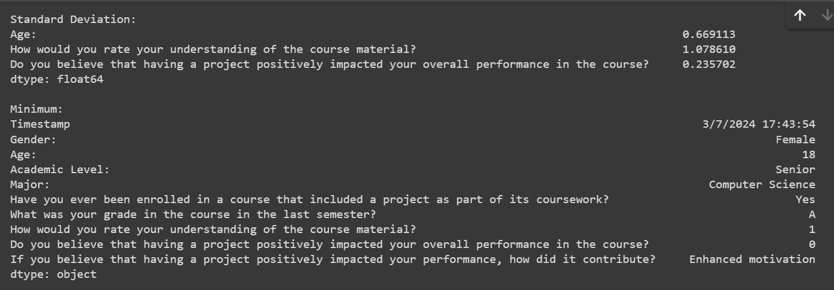

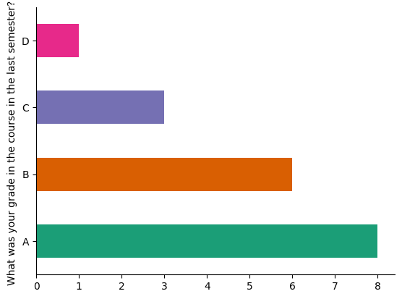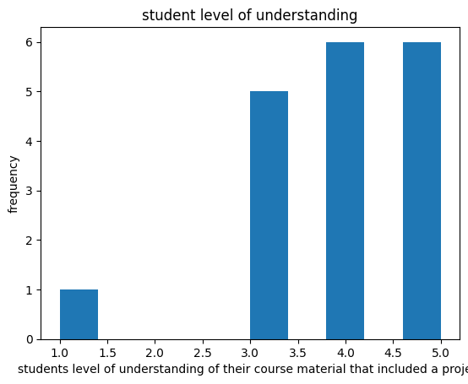

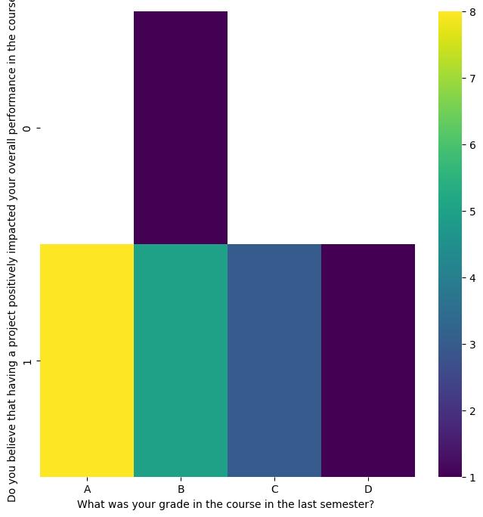

* From these graphs that I made with a python code, we can see that the course that the students took that had a project in its coursework had good understanding and that the mean of their grade is high, and they believe that having the project had increased their understanding of the course.

Forms response chart. Question title: If you believe that having a project positively impacted your performance, how did it contribute? 
. Number of responses: 18 responses.

* This is the result of how the students believe the projects help them in their courses.

# Conclusion

* Based on the results we've gathered and the analysis we've conducted, it's clear that incorporating a project into the coursework is highly beneficial for students. Not only does it enhance their learning experience, but it also improves their skill set and provides them with practical, hands-on experience. This approach not only helps students better understand the material but also prepares them more effectively for real-world applications of their knowledge

# Any potential issues

* My data collection design would be better if it had more quantitative variables than categorical because you can analyse the quantitative variables more and with them you can draw better graphs that describes your results.